**Business Scenario**

The Analytics team of a pharmaceutical company wants to design a dashboard to analyze the sales of products across various regions and brands. It wants to create a chart with User control functionality, so users can easily see the total Sales and “commission of external agents” categorized by brands and region.

The company’s database keep’s track of following data fields:

Brand Name, Company Name, Disease Medical Use, Invoice date, Company code, Ship-to-Country, Ship-to-Country Full Name, Sold-to party- Code, Sold-to party Country, Sold to party Country Full Name, Delivery Plant, Payment terms, External Agent, Sales quantity, Price TC /Kg, Revenue, External commissions, Month.

**Overview**

* Use the Saved Sample – Pharma database.
* Prepare table of Sales and “Commission to Agent” data by Company and Year.
* Create Column Chart for Sales and “Commission to external agent.”
* Create User Control Combo box.
* Link table with combo box.
* Create a dashboard.

The result should resemble the image below:

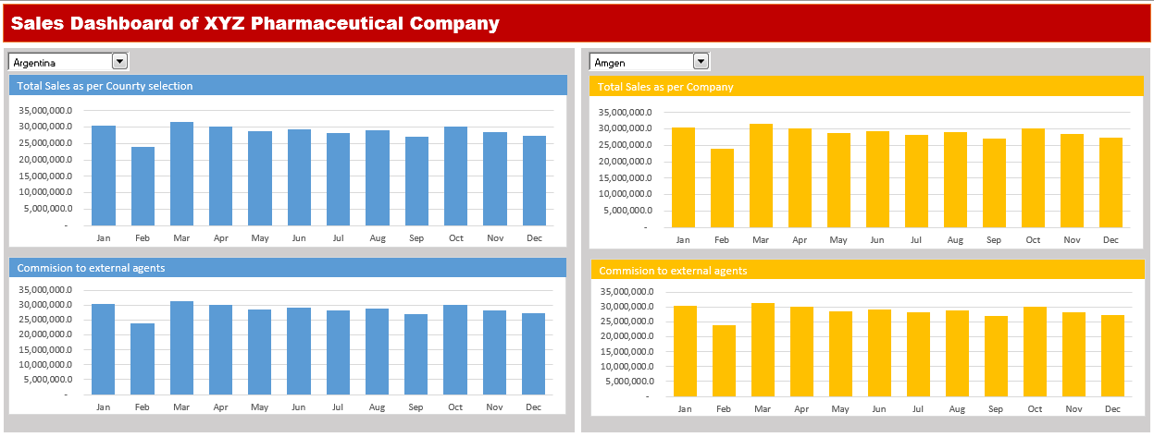

**P001**

**Step1 - Create Combo Box:**

* Insert Combo box for Companies and Countries list in the Dashboard Sheet.
* Click Developer Tab > Under Controls Panel > Click Combo box and draw.

Pass Input Range and Cell for combo box.

* Right-click the country list combo box > Click Format Control > Under Format Control Panel, Pass Input Range “Working!M2:M46” and Cell Link “Working!N1” from working sheet.
* Perform the Same steps for Companies Combo box, pass Input Range “Working!O2:O14” and Cell Link “Working!P1” from working sheet.

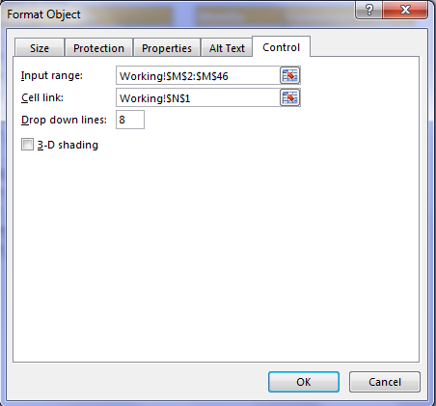

**P002**

Now, write the offset function in cell “N2” to fetch the country based on the selection in Countries combo box.

* Write the equal sign and then the function name.
* Pass the first argument as Cell “$M$1.”
* In the second argument, select the cell link cell “$N$1.”

Let’s perform the same steps to fetch the company based on the selection in the Companies combo box in Cell “P2”

* Write the equal sign and then the function name.
* Pass the first argument as Cell “$O$1.”
* In the second argument, select the cell link cell “$P$1.”

Let’s perform the second step now.

**P003**

**Step 2:**

Create Table of Sales Amount and “Commission to external agent” based on the selection in the Countries combo box.

Use the “Sumifs” formula to calculate total sales in the range B3 in working sheet.

* Write the equal sign and then enter the function name and open parenthesis.
* The first Argument is Sum_Range, select range Data!R:R, and then enter comma.
* Now, pass the second argument country column “criteria Range1” as Data!L:L, and enter comma.
* Pass the third argument “criteria1” “$N$2,” and enter comma.
* Pass the fourth argument as Data!T:T, and enter comma.
* Pass the fifth argument as “$A3.”
* Now, copy and paste the formula in Range B3:B14.

Now, write the function to calculate “Commission for External Agents” in range “E3:E14.”

* Write the equal sign and then enter the function name and open parenthesis.
* The first Argument is Sum_Range, select range Data!S:S, and then enter comma.
* Now, pass the second argument country column “criteria Range1” as Data!L:L, and enter comma.
* Pass the third argument “criteria1” “$N$2,” and enter comma.
* Pass the fourth argument as Data!T:T, and enter comma.
* Pass the fifth argument as “$D3.”
* Now, copy and paste the formula in Range E3:E14.

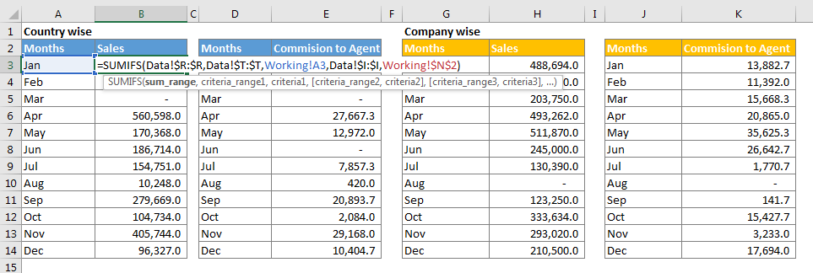

**Step 3:**

Now, create table of Sales Amount and “Commission to external agent” based on the selection in the company’s combo box.

Use the “Sumifs” formula to calculate total sales in the range H3 in working sheet.

* Write the equal sign and then enter the function name and open parenthesis.
* The first Argument is Sum_Range, select range Data!R:R, and then enter comma.
* Now, pass the second argument company column “criteria Range1” as Data!D:D, and enter comma.
* Pass the third argument “criteria1” “$P$2”and enter comma.
* Pass the fourth argument as Data!T:T, and enter comma.
* Pass the fifth argument as “$G3.
* Now, copy and paste the formula in Range H3:H14.

Now, write the function to calculate “Commission for External Agents” in the range K3.

* Write the equal sign and then enter the function name and open parenthesis.
* The first Argument is Sum_Range, select range Data!S:S, and then enter comma.
* Now, pass the second argument company column “criteria Range1” as Data!D:D, and enter comma.
* Pass the third argument “criteria1” “$P$2”, and enter comma.
* Pass the fourth argument as Data!T:T, and enter comma.
* Pass the fifth argument as “$J3.”
* Now, copy and paste the formula in Range K3:K14.

**P004**

**Step 4: Create Column Chart**

Create column chart for each table.

Select table (D2:E14), click insert tab > Under Charts Panel > Insert column chart.

Cut and Paste the chart in the Com box sheet.

Perform the same steps for other three tables.

Now, this is our sales dashboard, we can apply any color in the interior of cells and data series to format it.

